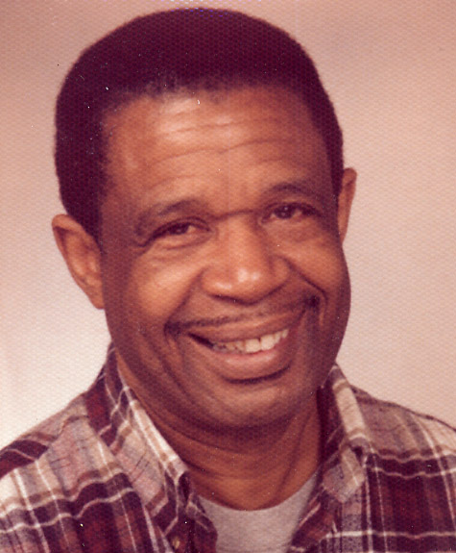
“Historical Sketches”

Lectures, Talks, Residencies and Consultations by:
Alex Pascall O.B.E.

Alex Pascall O.B.E. is a Cultural Historian, Journalist, Broadcaster, Playwright, Composer, Performer and Trade Unionist. A cultural griot with extensive knowledge and experience of Black and Caribbean cultural lifestyle in Britain, working nationally and internationally in creativity in education. He says …

“In my years of working in education, I have experienced how much can be taught when subject boundaries are taken away, especially for those who are eager to find ways to express themselves innovatively.”

Alex employs a code of teaching which helps students to formulate their ideas through drama, movement and literature for creative learning, with an organisational plan of subjects, before attempting written work; he is adept at keynote addresses, motivational lectures, INSET and school assemblies.

Client lists nationally and internationally include:
National Union of Teachers – Commonwealth Institute - BBC TV pre-school series ‘Teletubbies’- CDC (Children’s Discovery Centre) – Cambridge City Council – County Borough of Torfaen, South Wales, 39 schools – Education & Youth Departments, City & County of Swansea – University of Wales Newport - BBC Wales Radio & TV - One World Week - BBC Radios 2, 3 and 4 – Norwegian National Commission For UNESCO - Verbal Arts Centre, Londonderry, Northern Ireland – Wandsworth, Waltham Forest & Willesden Borough Council Libraries – The Victoria & Albert Museum – lecture circuit in Japan: Tokyo, Iwate, & Akita; creating and delivering workshop programmes that are challenging and interactive, as part of the drive to encourage students and the youth who are finding it difficult to focus within formal educational frameworks.

Alex Pascall is a communicator and performer with a wide repertoire of subject matters. He is well known and respected as a radio and television personality. Alex has played a pivotal role as adviser, writer and performer for the successful pre-school BBC TV ‘Teletubbies’ landmark World Series. He was awarded the O.B.E. by Her Majesty in 1996 for “Services to Community Relations”. He is a celebrated “Member of Honour” of the National Union of Journalists.
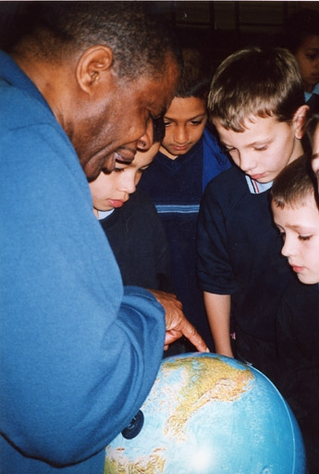
Topical Ideas: “Historical Sketches”
- The influence of Black music on the British music scene,
- The Black Media Presence in British Media,
- My First Day at School,
- We All Have Stories to Tell,
- The Crossing,
- Black British writers,
- They came before the Windrush,
- Food for Thought e.g. Caribbean Christmas,
- Caribbean culture on popular culture worldwide.

For further details, Tel: 01633 267367 / 07976 267367
Email: alex@ideasuk.co.uk
www.goodvibes-online.co.uk

